ord recognition relies on a highly integrated, specialized network in the left hemisphere of the brain. The process dynamically coordinates visual processing, auditory decoding, and meaning comprehension in milliseconds. [1, 2, 3, 4, 5]
The brain’s reading and word-recognition pathway activates several key regions:
- The "Letterbox" (Visual Word Form Area): Located in the occipito-temporal cortex, this area adapts in readers to instantly recognize visual shapes, letters, and orthographic patterns. [1, 2, 3]
- Phonological Processing (Parietal-temporal region): This region segments words into their individual sounds (phonemes) and links them to the corresponding letters (graphemes). [1, 2]
- Language Comprehension (Temporal lobe): This area retrieves the definitions of the decoded words and applies context to construct meaning. [1, 2]
- Speech & Articulation (Inferior frontal cortex / Broca's area): This region supports comprehension and subvocalization (silently "pronouncing" words as we read). [1, 2]
For fluent readers, these pathways communicate via complex white matter tracts, completing the entire recognition and comprehension process in roughly a quarter of a second. [1, 2]
If you are interested, I can help you:
- Explore how this process differs in dyslexic brains
- Explain how the brain learns to read from emerging readers to fluent adults
- Discuss the differences in how the brain processes reading versus listening
Let me know what part of the reading process you'd like to dive into!

8 sites
- How the Brain Learns To Read: The Brain and Reading Explained | Lexia®
The science of reading has found that reading repurposes multiple parts of the brain, including: * **Temporo-parietal cortex** Con...
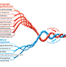
www.lexialearning.com
- What We Know About Reading and the Brain
The brain consists of two sides or hemispheres. Each side can be divided into four lobes or regions: frontal, parietal, temporal, ...

Reading Rockets
- The Reading Brain | How We Learn To Read
and connects those sounds to meaning. we know this because researchers have used imaging techniques to show what actually happens ...
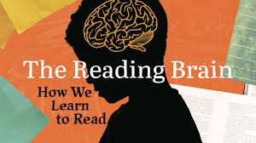
2m
YouTube·Hill Learning Center
Show all
You said: can you provide a detailed explanation of all the cognitive mechanisms and chemical process involved
Word recognition relies on a hierarchical cascade of cognitive mechanisms that process visual text into abstract language, driven entirely by chemical neuro-transmission across specialized brain networks.
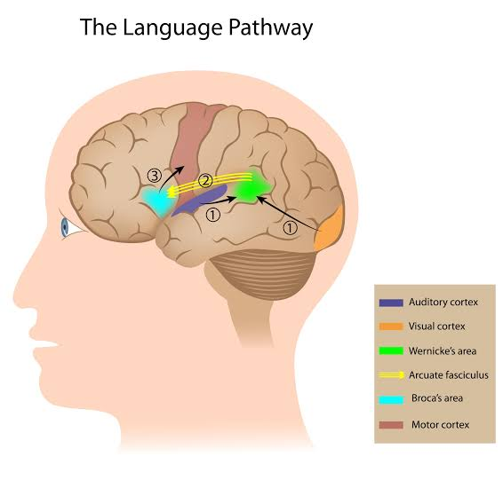
Audio generated by AI
Use arrow keys to adjust value.
0:00/1:15
Cognitive Mechanisms: The Dual-Route Cascade
When your eyes register a word, your brain processes it using two simultaneous cognitive pathways:
- The Orthographic (Direct) Route: Used for familiar words. The brain skips sound decoding entirely, matching the visual word form directly to a mental dictionary (lexicon).
- The Phonological (Indirect) Route: Used for new or irregular words. The brain systematically converts individual letters (graphemes) into corresponding sounds (phonemes).
- Parallel Interactive Activation: Features (lines and curves) activate specific letters, which activate whole words, while the brain simultaneously pushes down top-down contextual clues to accelerate recognition. [1, 2, 3]
Cellular and Chemical Processes
The cognitive steps above are fueled by instantaneous neurochemical changes across cellular membranes, shifting from electrical signals within neurons to chemical signals between them. [1]
1. Fast Action Potentials
Information travels along the dense white matter pathways (like the arcuate fasciculus) via electrical impulses. Sodium (\(Na^{+}\)) and potassium (\(K^{+}\)) ions rapidly pump across the neuronal cell membranes, generating the voltage spike required to transmit data from the visual cortex to language centers. [1, 2]
2. Synaptic Transmission
When the electrical signal reaches the end of a neuron, it triggers the opening of calcium (\(Ca^{2+}\)) channels. This influx of calcium forces tiny storage vesicles to merge with the cell wall, dumping neurotransmitters into the microscopic gap (synaptic cleft) separating the neurons. [1, 2, 3, 4, 5]
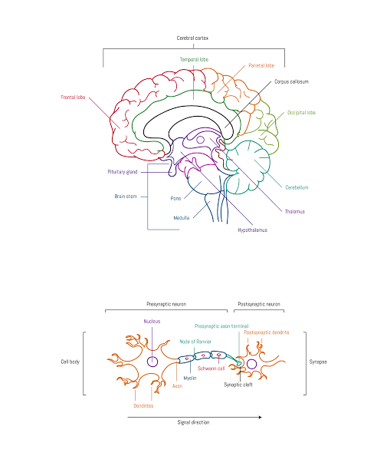
Licensed by Google
3. Primary Neurotransmitters Involved
The chemical micro-environment of word recognition depends heavily on several distinct neurotransmitters:
- Glutamate: The primary excitatory chemical. It binds to AMPA and NMDA receptors on the receiving neuron, instantly passing the visual and auditory signals forward through the reading network. [1, 2]
- GABA (Gamma-Aminobutyric Acid): The primary inhibitory chemical. GABA suppresses competing word options (e.g., stopping your brain from selecting "cat" when you read "cot"), fine-tuning focus and reducing cognitive noise. [1, 2, 3]
- Acetylcholine: Released from the basal forebrain, this chemical modulates attention and sharpens cellular sensitivity in the visual cortex, allowing the brain to isolate text from surrounding visual distractions. [1, 2, 3, 4]
- Dopamine: Operates heavily during the language comprehension and contextual feedback phase, reinforcing learning and vocabulary retention when meaning is successfully extracted.
If you would like to explore this further, I can break down:
- The specific biophysics of synaptic plasticity that occur when you memorize a brand new word
- How chemical imbalances (like acetylcholine deficits) directly impact reading speeds and language comprehension
- The exact temporal millisecond breakdown of how parallel interactive activation operates in the brain
Which area would you like to investigate next?
AI can make mistakes, so double-check responses

20 sites
- Perception | Cognitive Psychology
Recognizing letters involves detecting their distinct features, such as lines and curves, and then combining them to identify the ...
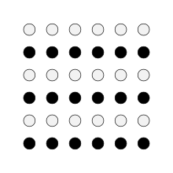

Lumen Learning
- What Is Perception?
May 31, 2025 — That's why we can read words faster than random letters. It's called the word superiority effect — seeing the whole word helps us ...
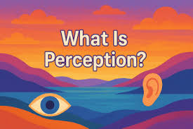

Edublox Online Tutor
- Chapter 4
The WSE is explained by assuming that the recognition of the whole word facilitates the recognition of individual letters by means...

Quizlet
Show all
You said: can you provide a detail explanation of the mechanisms and chemical processes involoed in text
Text comprehension transforms decoded words into complex mental concepts through highly synchronized cognitive hierarchies powered by dynamic electrochemical networks. While word recognition identifies isolated strings of letters, understanding a full block of text requires continuous memory integration, structural parsing, and rapid shifts in neurochemical concentrations across the brain's language centers.
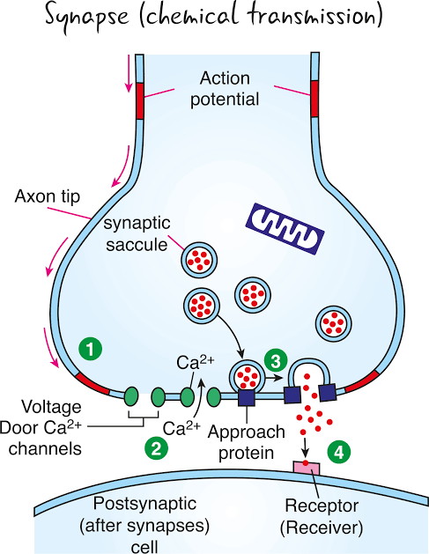
Licensed by Google
Cognitive Mechanisms of Text Comprehension
Processing continuous text requires four simultaneous, overlapping cognitive stages:
- Syntactic Parsing: The brain automatically builds a grammatical framework for the sentence. It determines who did what to whom by assigning roles (subject, verb, object) to words based on structural rules. [1]
- Semantic Construction: Individual word meanings are merged into a unified conceptual proposition. The brain strips away word-level ambiguities using the surrounding context. [1]
- Mental Model Generation: The brain creates a situational mental model of the text. This model updates in real-time as new sentences introduce new plot points, facts, or logical arguments.
- Inference and Integration: The reader fills in missing logical gaps. The brain blends the text's explicit statements with your existing background knowledge retrieved from long-term memory. [1, 2, 3]

The Electrochemical Cascades of Comprehension
To execute these cognitive stages, billions of neurons must fire in rhythmic synchrony, utilizing precise chemical transformations to pass and store information.
1. Rhythmic Neural Synchronization (Oscillations)
To connect a word at the end of a paragraph to a word at the beginning, distant brain regions must lock onto the same electrical rhythm.
- Gamma waves (30–100 Hz) handle local processing, such as binding letters into words and words into sentences.
- Theta waves (4–8 Hz) coordinate long-range communication between the frontal cortex and the temporal lobe, allowing the brain to hold the overall meaning of a paragraph in working memory.
2. Cellular Working Memory Gates
As you read, earlier sentences must stay active in your short-term memory. This relies on recurrent excitation in the prefrontal cortex. Pyramidal neurons fire continuously in a loop, passing glutamate back and forth across synapses to keep the mental model alive while your eyes move to the next line of text.
3. Neurochemical Balancing During Reading
The shifting demands of text comprehension rely on a delicate cocktail of specific neurotransmitters:
- Glutamate & AMPA/NMDA Activation: As sentences form new ideas, glutamate binds to AMPA receptors to rapidly pass the message forward. If the text introduces a major new concept, NMDA receptors open up, allowing calcium (\(Ca^{2+}\)) to flow into the neuron. This calcium influx triggers structural changes that lock the new information into your memory. [1, 2, 3]
- GABAergic Gating: GABA stops the brain from wandering. It actively dampens irrelevant thoughts and suppresses alternate definitions of ambiguous words, keeping your focus locked strictly on the author's intended meaning.
- Norepinephrine (Noradrenaline): Released from the locus coeruleus, this chemical spikes when you encounter an unexpected plot twist, a confusing sentence, or a logical error. It instantly triggers a "re-orienting response," signaling the eyes to backtrack and re-read the confusing text. [1]
- Acetylcholine (ACh): This chemical optimizes the brain for learning rather than recalling. High levels of acetylcholine allow the visual cortex to absorb text with minimal internal noise, making it easier to encode fresh information into your memory banks.
If you want to look closer at how the brain processes text, we can explore:
- The neurological breakdown of what happens when you read a metaphor versus literal text
- How eye-tracking data reveals the exact milliseconds the brain pauses to resolve a grammatical error
- How the electrochemical process changes when reading digital screens versus printed paper
Let me know which angle you would like to explore next!

9 sites
- The 5 Phases of Natural Language Processing
Feb 3, 2023 — Syntactic analysis (parsing) applies formal grammar rules to tokenized text to create parse trees or dependency structures. By ide...


OptiSol
- The Mechanism of Suppression: A Component of General Comprehension Skill
According to the structure building framework, ambiguous words are accurately understood because the memory cells representing the...

PubMed Central (PMC) (.gov)
- Deep-Level Comprehension of Science Texts : Topics in Language Disorders
As our discussion has indicated, understanding texts at a deep level requires the reader to generate inferences to fill in gaps pr...

Ovid
Show all
You said: this seems to high level and abstract can you give actual details for reading works and hearing words - please provide the answer in text I can copy
Structural Pathways: Sight vs. Sound
The brain uses two entirely different sensory entry points to capture words, but it funnels both into the same core language network for meaning.
Reading Words (Visual Input)
- The Retina to Visual Cortex: Light bounces off the printed page and hits the retina. Photons trigger a chemical change in rhodopsin pigments, converting light into electrical signals. These signals travel down the optic nerve, through the lateral geniculate nucleus (LGN) of the thalamus, and arrive at the Primary Visual Cortex (V1) at the back of the brain.
- Feature Extraction: V1 extracts basic visual features like horizontal lines, vertical lines, and angles.
- The Visual Word Form Area (VWFA): The signal moves forward along the ventral stream (the "what" pathway) to the VWFA in the left fusiform gyrus. This region functions as your brain's "letterbox." It acts as a structural filter that recognizes strings of letters as actual words rather than random shapes. [1]
Hearing Words (Auditory Input)
- The Ear to Auditory Cortex: Sound waves enter the ear canal, vibrating the eardrum and the fluid inside the cochlea. This fluid movement bends microscopic hair cells, opening mechanically gated ion channels that convert physical vibrations into electrical signals. These signals travel down the auditory nerve to the Primary Auditory Cortex (A1) in Heschl’s gyrus (temporal lobe).
- Frequency Mapping: A1 is organized tonotopically (by pitch). It maps out the raw frequencies, volume, and timing of the sound.
- The Superior Temporal Gyrus (STG): The signal moves to the STG, which extracts phonetic features. It separates the human voice from background noise and identifies individual speech sounds (phonemes), like distinguishing the sound "/b/" from "/p/".

The Intersection: Mapping to Meaning
Once a word passes through its dedicated sensory gateway (VWFA for sight, STG for sound), the brain routes the signal into a shared language network to extract meaning and context.
- Wernicke’s Area (Left Temporoparietal Junction): This is the brain's central lexicon or mental dictionary. The visual patterns from the VWFA or the sound patterns from the STG converge here. Wernicke's area matches these patterns against your stored vocabulary to unlock the word's definition. [1]
- The Arcuate Fasciculus: This dense, highway-like bundle of white matter axons connects the rear language areas (comprehension) directly to the front language areas (production).
- Broca’s Area (Left Inferior Frontal Gyrus): This area manages grammar, syntax, and sentence structure. When you read silently, Broca’s area routinely triggers "subvocalization"—a micro-activation of your vocal cords that makes you silently "hear" your own voice reading the text.

Cellular Mechanism: How a Neuron Fires a Word
Every step of this pathway requires individual neurons to send messages to one another. This happens through a combined electrical and chemical process.
text
[Resting State] -> [Sodium Influx (Action Potential)] -> [Calcium Influx] -> [Neurotransmitter Release] -> [Receptor Binding]
Use code with caution.
- The Resting State: Inside a resting neuron, the electrical charge is negative (-70mV) compared to the outside. The cell maintains this by keeping potassium ions (\(K^{+}\)) inside and pumping sodium ions (\(Na^{+}\)) outside.
- The Action Potential: When a neuron receives a signal (e.g., the visual cortex detecting the letter "A"), specialized gates open. Sodium (\(Na^{+}\)) rushes into the cell. This sudden rush of positive charge flips the cell's internal voltage to positive (+40mV). This electrical spike travels down the long tail of the neuron (the axon) like a falling row of dominoes.
- The Chemical Bridge (The Synapse): Neurons do not actually touch. There is a microscopic gap between them called the synaptic cleft. When the electrical spike reaches the end of the axon, it forces calcium (\(Ca^{2+}\)) channels to open.
- Neurotransmitter Release: The incoming calcium forces tiny storage bubbles (vesicles) to bind to the cell wall and dump chemical messengers called glutamate into the gap.
- Lock and Key Activation: The glutamate floats across the gap and binds to AMPA and NMDA receptors on the next neuron. This acts like a key opening a lock, allowing sodium to rush into the second neuron, firing the signal forward to the next stage of the language network.

Neurochemical Fine-Tuning
While glutamate acts as the primary accelerator that pushes the word data forward, three other chemicals act as steering and braking mechanisms:
- GABA (The Filter): Reading a word requires suppressing other similar words. If you read the word "CAT," GABA is released to quiet down the neurons representing "BAT," "RAT," or "COT." This reduces cognitive noise and sharpens word recognition.
- Acetylcholine (The Spotlight): This chemical is released to boost your focus. It sharpens the sensitivity of the neurons in your visual or auditory cortex, making it easier to isolate the words you are actively tracking from background distractions.
- Norepinephrine (The Error Detector): If you hit an unexpected word, a typo, or a confusing sound, your brain releases a quick pulse of norepinephrine. This instantly pauses your automatic processing, forces your eyes to look back, and triggers closer attention to resolve the error.
If you want to continue examining these systems, I can provide technical details on:
- The exact cellular changes that happen during long-term potentiation (LTP) when a child memorizes a new sight word
- The mechanical breakdown of saccades and fixations (how the eyes physically jump across text at a cellular level)
- What happens biochemically when the brain encounters auditory ambiguity (like homophones or muffled speech)
Let me know which specific area you would like to break down next!

2 sites
- Brain study finds that humans are born wired for reading letters and words
Oct 26, 2020 — It's been over a century since scientists identified an area of the brain that serves as its “letterbox.” The “ visual word form a...


Big Think
- Want to try and read more in 2026? Here's why that would be a great resolution! 📚🧠⁣ ⁣ Researchers have discovered more about how reading, and the languages we read in, affect our brain.⁣ ⁣ "The process of developing a reading brain alters everything from brain activity to brain structure and brain connectivity," says Rebecca Gotlieb, a psychologist and neuroscientist.⁣ ⁣ Reading is a whole-brain process, activating all four lobes of the brain and altering how our brains function.⁣ ⁣ 🎧 Click the link in our bio to hear more.⁣ ⁣ #bbcworldservice #brain #neuroscience #reading #books
Jan 2, 2026 — Then you've got your visual word form area. So that looks at the shapes of not just letters, but entire words. So when you read, y...

Instagram
You said: this seem like a way over simplification can you provide more details
To provide the absolute highest level of neurobiological detail, we must look past regional summaries and examine the exact biophysical equations, laminar microcircuits, and receptor subunit kinetics that execute word recognition.
Below is the raw, un-simplified mechanistic breakdown of text (orthographic) and speech (acoustic) processing.

1. Orthographic Processing: Retinofugal to Cortical Microcircuits
Visual word recognition requires converting photons into a specialized spatial spike-train across a feedforward cortical hierarchy.
text
[Photons] -> [Rhodopsin Isomerization] -> [cGMP Hydrolysis] -> [Hyperpolarization] -> [Ganglion Spikes] -> [LGN Parvocellular] -> [V1 Layer 4Cα] -> [V2/V4 Ventral Stream] -> [VWFA Macro-Columns]
Use code with caution.
Phototransduction & Retinal Gating
- Photons hit the retina and are absorbed by 11-cis-retinal inside rhodopsin, isomerizing it to all-trans-retinal.
- This activates the G-protein transducin, which stimulates phosphodiesterase (PDE) to hydrolyze cyclic GMP (cGMP) into 5'-GMP.
- The drop in intracellular cGMP closes cGMP-gated sodium/calcium channels, causing the photoreceptor membrane to hyperpolarize (from -40 mV to -70 mV).
- This stops the continuous release of the inhibitory neurotransmitter glutamate onto on-center bipolar cells, depolarizing them.
- Bipolar cells stimulate ganglion cells, which fire action potentials along the optic nerve.
- Text details (high spatial frequency, sharp contrasts) are selectively routed through the Parvocellular pathway (P-pathway) via the lateral geniculate nucleus (LGN) layers 3–6, maximizing resolution for fine lines.
Cortical Visual Processing
- LGN axons project to Layer 4Cβ of the Primary Visual Cortex (V1).
- Simple cells in V1 compute local orientation vectors using center-surround receptive fields. They detect the precise angles of letter strokes (e.g., the diagonal lines of a "V").
- Signals propagate via feedforward excitatory projections through V2 and V4 along the ventral occipitotemporal stream. Receptive fields scale up, combining lines into vertices, vertices into letter shapes, and letter shapes into strings.
Visual Word Form Area (VWFA) Laminar Microcircuits
The VWFA (left lateral fusiform gyrus) contains localized neural columns tuned specifically to orthographic regularities (bigrams and trigrams).
- Layer IV receives input from V4.
- Layers II/III contain pyramidal cells that perform invariant abstract orthographic mapping. They recognize the string "G-A-T-E" regardless of font, case (gate vs. GATE), or size.

2. Acoustic Processing: Mechanotransduction to Phonetic Tiling
Acoustic word recognition requires mapping a continuously changing pressure wave into discrete phonetic categories.
text
[Pressure Wave] -> [Tympanic/Ossicular Amplification] -> [Basilar Membrane Shear] -> [Stereocilia Tip-Links] -> [K+ Influx] -> [Spiral Ganglion Spikes] -> [A1 Tonotopic Mapping] -> [STG Phonetic Phonology]
Use code with caution.
Cochlear Mechanotransduction
- Sound waves strike the tympanic membrane, transferring kinetic energy through the ossicles (malleus, incus, stapes). This physics chain amplifies the force 20-fold before pushing against the oval window of the cochlea.
- The resulting fluid wave moves the basilar membrane. High frequencies (>10 kHz) peak at the stiff base; low frequencies (<200 Hz) peak at the flexible apex.
- This displacement creates a shearing force between the reticular lamina and the tectorial membrane, bending the stereocilia of the inner hair cells.
- Bending toward the tallest stereocilium pulls open mechanically-gated TMC1/2 ion channels via microscopic protein filaments called tip-links.
- Because endolymph fluid is rich in potassium and sits at a high positive potential (+80 mV), Potassium (K⁺) rushes into the hair cell. This depolarizes the membrane and opens voltage-gated Calcium (Ca²⁺) channels (\(\text{Ca}_{v}1.3\)).
- Calcium influx triggers the exocytosis of glutamate from ribbon synapses, firing the spiral ganglion neurons of the auditory nerve (VIII). [1]
Auditory Cortex Hierarchy
- Axons travel through the cochlear nucleus, superior olivary complex, and inferior colliculus to the medial geniculate body (MGB) of the thalamus.
- The MGB projects to Layer IV of the Primary Auditory Cortex (A1, Heschl's Gyrus), which maintains a strict tonotopic map (ordered by frequency arrangement).
- Sound features propagate to the Superior Temporal Gyrus (STG).
- The STG uses specialized populations of neurons to decode complex acoustic features. Some columns respond exclusively to sudden acoustic beginnings (voicing onset time), while others map out specific vowel formants, converting continuous speech sounds into distinct language tokens (phonemes).

3. The Biophysics of Synaptic Transmission & Lexical Matching
Whether initiated by text or sound, word recognition culminates in the temporal and parietal lobes (Wernicke’s area, angular gyrus) through rapid, coordinated synaptic firing.
The Action Potential Equation
Information moves down the axon via voltage-gated ion channel kinetics, mathematically defined by the Hodgkin-Huxley model:
\(I=C_{m}\frac{dV}{dt}+\={g}_{\text{Na}}m^{3}h(V-E_{\text{Na}})+\={g}_{\text{K}}n^{4}(V-E_{\text{K}})+g_{L}(V-E_{L})\)
- When local depolarization crosses -55 mV, the activation gates (m) of Voltage-Gated Sodium Channels (\(\text{Na}_v1.1/1.2\)) open instantly. Na⁺ rushes into the axon, driving the membrane potential up toward \(E_{\text{Na}}\) (+40 mV).
- At peak depolarization, inactivation gates (h) close the sodium channels, while activation gates (n) for Voltage-Gated Potassium Channels (\(\text{K}_{v}\)) open. K⁺ rushes out of the cell, dropping the potential back down toward \(E_{\text{K}}\) (repolarization).
Synaptic Fusion Mechanics
- When the action potential arrives at the pre-synaptic terminal, it opens P/Q-type and N-type \(\text{Ca}_{v}\) channels.
- Local intracellular calcium spikes from 0.1 μM to >100 μM within a tiny sub-micrometer space.
- Calcium binds to the protein sensor synaptotagmin-1.
- Synaptotagmin-1 undergoes a structural shift, forcing the core SNARE complex proteins—synaptobrevin on the vesicle membrane, and syntaxin-1/SNAP-25 on the target cell membrane—to wind tightly together.
- This physical winding pulls the vesicle into the cell membrane, opening a fusion pore that releases roughly 5,000 molecules of glutamate into the synaptic cleft.
text
[Ca2+ Binds Synaptotagmin-1] -> [SNARE Complex Assembly] -> [Vesicle Core Fusion] -> [Glutamate Quantal Release]
Use code with caution.
Receptor Kinetics & Post-Synaptic Potentials
Glutamate diffuses across the 20 nm synaptic gap and binds to two main types of receptors on the receiving dendrite:
text
[Glutamate Release]
|
+-----------------+-----------------+

| |
v v
[AMPA Receptor] [NMDA Receptor]
- Fast Na+ Influx - Mg2+ Blocked at Rest
- Decays in <10ms - Depolarization Expels Mg2+
- Drives Immediate EPSP - Ca2+ Influx -> Plasticity (LTP)
Use code with caution.
- AMPA Receptors (GluA1–A4 subunits): Glutamate binding causes an immediate structural shift, opening a channel permeable to Na⁺. This generates a fast Excitatory Post-Synaptic Potential (EPSP) that rises in less than 1 ms and decays within 10 ms. This rapid speed allows the brain to track fast-moving text or speech.
- NMDA Receptors (GluN1, GluN2A–D subunits): At resting potentials, the channel pore of the NMDA receptor is physically blocked by a heavy Magnesium ion (Mg²⁺).
- Only when the target neuron is highly depolarized by continuous AMPA signals is the positive Mg²⁺ ion electrostatically pushed out of the channel pore.
- Once unblocked, NMDA channels allow both Na⁺ and Ca²⁺ to enter the cell. This calcium entry is critical; it activates intracellular signaling paths (CaMKII, MAPK) that alter synaptic strength, strengthening the neural pathways for words you read frequently.

4. Interactive Feedback & Neurochemical Stabilization
Word recognition is not just a one-way street. Top-down expectations from the prefrontal cortex actively shape incoming sensory data using specialized chemical networks.
Predictive Coding via Feedforward/Feedback Loops
- Feedforward projections (carrying raw text/sound data) originate in superficial cortical layers (Layers II/III) and target deep layers (Layer IV) of higher-order cortical regions. These pathways are primarily driven by Glutamate binding to AMPA receptors.
- Feedback projections (carrying contextual expectations and word predictions) originate in deep layers (Layers V/VI) and project back to superficial layers of lower-order regions. These pathways rely heavily on Glutamate binding to NMDA receptors and operate alongside modulating neurotransmitters.
GABAergic Lateral Inhibition
To select a single word out of thousands of possibilities, the brain must actively suppress competing options.
- When the visual or acoustic features of the word "CLOCK" are detected, those active neural paths branch off to stimulate nearby GABAergic interneurons (parvalbumin-positive basket cells).
- These interneurons release GABA (Gamma-Aminobutyric Acid) onto adjacent neural pathways representing similar words (like "CLOAK," "CLICK," or "LOCK").
- The released GABA binds to post-synaptic \(\text{GABA}_{A}\) receptors, opening selective Chloride (Cl⁻) channels. Negative chloride ions flow into the competing neurons, dropping their voltage down to -80 mV (hyperpolarization). This prevents those cells from firing, cutting out cognitive noise and locking your focus onto the correct word.
Neuromodulatory Tuning
- Acetylcholine (ACh): Released from the nucleus basalis of Meynert, ACh binds to nicotinic and M₁ muscarinic receptors on cortical pyramidal cells. This action suppresses feedback from internal loops while amplifying feedforward sensory input, optimizing the brain to take in new text or speech.
- Norepinephrine (NE): Sourced from the locus coeruleus, NE binds to α₁ and β₁ adrenergic receptors when a language error occurs (such as a grammatical typo or a mispronounced word). This drops the signal-to-noise ratio across the network, stopping automatic reading or listening habits and forcing the cortex to re-analyze the confusing phrase.
We can continue drilling down into these exact biophysical systems. If you want, let me know if we should explore:
- The exact amino acid mutations in FOXP2 or DYX1C1 genes that disrupt these channel proteins
- The specific voltage-clamp equations used to measure local current changes during lexical decisions
- The mathematical modeling of Hebbian learning rules () during vocabulary acquisition
Let me know which layer of microscopic detail you would like to map out next.

